INTERNATIONAL ASSOCIATION OF PLUMBING AND MECHANICAL OFFICIALS UNIFORM
EVALUATION SERVICE EVALUATION CRITERIA FOR
SINGLE SKIN STEEL ROOF AND WALL PANELS

EC 011-201X
(Adopted - September 2013, Revision – June 2015, Proposed Revision May 2019)

  - INTRODUCTION

  - Purpose: This Evaluation Criteria establishes the requirements for single skin steel roof and wall panels (herein referred to as “panels”) to be recognized in an evaluation report independently reviewed by an evaluation service agency under the 2018, 2015, and 2012 International Building Code® (IBC) and the 2018, 2015, and 2012 International Residential Code® (IRC). Bases of recognition are IBC Section 104.11 and IRC Section R104.11.

This Evaluation Criteria provides guidelines for the calculation of strength, serviceability and testing of panels based on code provisions and for conditions where the codes do not address the necessary requirements.

  - Scope: This Evaluation Criteria provides a basis for calculating, testing and evaluating panels for positive and negative out-of-plane load capacities, section properties, web crippling, and diaphragm shear resistance. In addition, standards are provided for optional fire resistance, wind-blown debris resistance, air and water infiltration resistance, drag resistance evaluation, in-plane shear resistance, and clip/fastener attachment schedules.

The Scope of this Evaluation Criteria excludes the following items:
    - Composite panel systems.
    - Panel materials other than steel.

REFERENCED STANDARDS

  - The edition of the Referenced Standards shall be as indicated or shall be consistent with provisions of Chapter 35 of the applicable edition of the IBC or Chapter 44 of the IRC upon which compliance is based.

American Forest and Paper Association
NDS ANSI/AWC National Design Specification® (NDS) for Wood Construction NDS ANSI/AF&PA National Design Specification® (NDS) for Wood Construction

American Concrete Institute
ACI 318 Building Code Requirements for Structural Concrete

American Iron and Steel Institute

AISI S100-07-S2-10 Supplement No. 2 to the North American Specification for the Design of Cold- Formed Steel Structural Members, 2007 Edition (2012 IBC and IRC)

Copyright © 2019 by International Association of Plumbing and Mechanical Officials. All rights reserved. Printed in the United States. No part of this publication may be reproduced, stored in an electronic retrieval system, or transmitted, in any form or by any means, electronic, mechanical, photocopying, recording, or otherwise, without the prior written permission of the publisher. Ph: 1-877-4IESRPT • Fax: 909.472.4171 • Web: www.iapmoes.org • 5001 East Philadelphia Street • Ontario, California 91761-2816 ––USA

AISI S100-12 North American Specifications for the Design of Cold-Formed Steel Structural Members (2015 IBC)
AISI S100-16 North American Specifications for the Design of Cold-Formed Steel Structural Members (2018 IBC)
AISI S310-16 North American Standard for the Design of Profiled Diaphragm Panels

AISI S904-13 or -17 Test Standard for Determining the Tensile and Shear Strengths of Steel Screws
AISI S905-13 or -17 Test Standard for Determining the Load-Carrying Strength of Panels and Anchor-to-Panel Attachments for Roof or Siding Systems Tested in Accordance With ASTM E1592
AISI S906-13 or -17 Test Standard for Determining the Load-Carrying Strength of Panels and Anchor-to-Panel Attachments for Roof or Siding Systems Tested in Accordance With ASTM E1592
AISI S909-13 or -17Test Standard for Determining the Web Crippling Strength of Cold-Formed Steel Flexural Members

ASTM International
ASTM A370-14 Standard Test Methods and Definitions for Mechanical Testing of Steel Products
ASTM C1513-13 Standard Specification for Steel Tapping Screws for Cold-Formed Steel Framing Connections
ASTM E108 Standard Test Methods for Fire Tests of Roof Coverings
ASTM E119 Test Methods for Fire Tests of Building Construction and Materials
ASTM E283 Standard Test Method for Determining Rate of Air Leakage Through Exterior Windows, Curtain Walls, and Doors Under Specified Pressure Differences Across the Specimen
ASTM E331 Standard Test Method for Water Penetration of Exterior Windows, Skylights, Doors, and Curtain Walls by Uniform Static Air Pressure Difference

ASTM E1592 Standard Test Method for Structural Performance of Sheet Metal Roof and Siding Systems by Uniform Static Air Pressure Difference
ASTM E1646-95 (11) Standard Test Method for Water Penetration of Exterior Metal Roof Panel Systems by Uniform Static Air Pressure Difference
ASTM E1680-11 Standard Test Method for Rate of Air Leakage Through Exterior Metal Roof Panel Systems
ASTM E1886 Standard Test Method for Performance of Exterior Windows, Curtain Walls, Doors, and Impact Protective Systems Impacted by Missiles(s) and Exposed to Cyclic Pressure Differentials
ASTM E1996 Standard Specification for Performance of Exterior Windows, Curtain Walls, Doors, and Impact Protective Systems Impacted by Windborne Debris in Hurricanes

International Organization for Standardization
ISO/IEC 17011:2017 Conformity Assessment -- General Requirements for Accreditation Bodies Accrediting Conformity Assessment Bodies

ISO/IEC 17020:2012 Conformity Assessment -- Requirements for the Operation of Various Types of Bodies Performing Inspection
ISO/IEC 17025:2017 General Requirements for the Competence of Testing and Calibration Laboratories
ISO/IEC 17065:2012 Conformity assessment – Requirements for Bodies Certifying Products, Processes and Services

Underwriters’ Laboratories
UL 263 Standard for Fire Tests of Building Construction and Materials

UL 790 Standard Test Methods for Fire Tests of Roof Coverings

DEFINITIONS

  - General: Terms not defined in this section, applicable codes, or referenced standards shall have the ordinary accepted definition for the context for which they are intended.

Definitions:

3.2.1 Analytical Theory: A mathematic equation or set of equations used to predict the load capacity of panels over a range of panel assembly conditions (i.e. panel gage, material grade, width, clip or fastener attachment spacing, etc.).

3.2.2 Clip: A mechanical device used to connect the panel to the support member through interlocking means or by the use of mechanical fasteners.

3.2.3 Concealed Fastener Panel: A cold-formed, sheet steel panel utilizing a clip or other fastener attachment method that is not exposed to the outside of the finished product. Figure 1 illustrates examples of typical concealed fastener panel types.

Figure 1: Examples of Concealed Fastener Panel Types

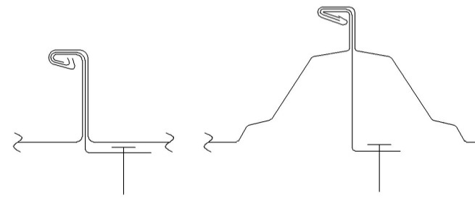
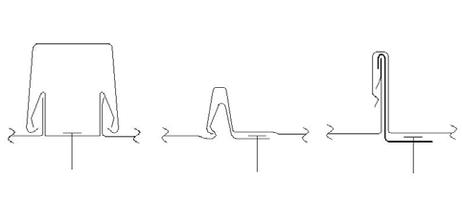
Mechanical seam Snap Together Seam
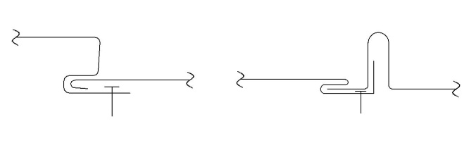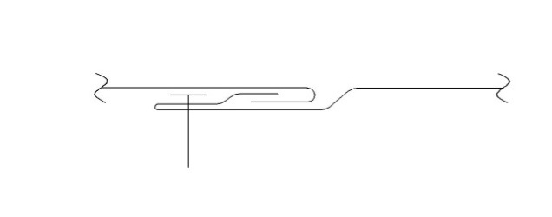
Integral Seam Hooked Seam

3.2.4 Evaluation Service Agency: Organization evaluating building products or finished construction for conformance to applicable codes and standards and publishing report or listing documents summarizing conclusions. The agency shall be accredited for the applicable product scope in accordance with ISO/IEC Standard 17065. The agency’s accreditation shall be issued by an accreditation body conforming to ISO/IEC 17011 and that is a signatory of the International Laboratory Accreditation Cooperation (ILAC) Mutual Recognition Arrangement (MRA) or another approved agency.

3.2.5 Exposed Fastener Panel: A cold-formed, sheet steel panel that is attached to the substrate by driving fasteners through the exterior of the panel and into the support member. These panels are also commonly referred to as corrugated or through-fastened panels. Figure 2 illustrates examples of typical exposed fastener panel types.

Figure 2: Examples of Exposed Fastener Panels
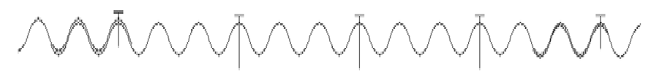
3.2.6 Negative Load: An out-of-plane load applied to the panel acting away from support members.

3.2.7 Positive Load: An out-of-plane load applied to the panel acting toward the support members.

3.2.8 Supporting member: A structural steel section, cold-formed steel structural section (e.g. cee, zee, hat), steel deck, dimensional lumber, wood structural panels (oriented strand board (OSB), or plywood) used as a base to securely fasten the panels down to.

BASIC INFORMATION

  - Panel Materials:

    - Permitted Roof Panel Materials: Roof panels shall be fabricated from cold-formed steel complying with the requirements of AISI S100-16 Section A3 or AISI S100-12 and -07-S2-10 Section A2, IBC Section 1507.4.3 or IRC Section
    - R905.10.3 as applicable.

    - Permitted Wall Panel Materials: Wall panels shall be fabricated from cold-formed steel complying with the requirements of AISI S100-16 Section A3 or AISI S100-12 or -07-S2-10 Section A2 and IBC Section 1405.2. Corrosion protection shall comply with IBC Table 1507.4.3(2).

    - Panel Material Properties: All steels used for testing shall have traceability back to mill certifications that clearly identify the grade designation, actual base metal thickness, yield strength, tensile strength and elongation. In absence of any of the required information, each coil of steel used to produce panel test samples shall be tested in accordance with ASTM A370.

  - Supporting Member Materials: Support members shall be of structural steel, cold-formed steel, lumber, wood structural panels, or concrete, complying with the requirements of the appropriate section of the IBC or IRC as applicable.

  - Fasteners: Fastening system shall be compatible with the material type, thickness and grade of the supporting members. Common fastener sizes for each panel shall be listed in the report.

  - Testing Laboratories: Testing laboratories shall be accredited for the applicable testing procedures in accordance with ISO/IEC 17025 by a recognized accreditation body conforming to ISO/IEC 17011. Testing at a non-accredited laboratory shall be permitted by the evaluation service agency, provided the testing is conducted under the supervision of an accredited laboratory and the supervising laboratory issues the test report.

  - Test Reports: Test reports shall be in compliance with Test Report Requirements Procedure (ES-
025) or equivalent and submitted to the evaluation service agency for generation of evaluation reports. Required and optional items to be included in the test reports are found in Table 1 of this criteria.

  - Test Product Requirements: Steel roof and wall components provided for tests under this Evaluation Criteria shall be representative of typical production and correlated by the testing laboratory or accredited inspection agency to the product specifications.

  - Panel Information: Panel and associated clip dimensioned drawings shall be submitted to the evaluation service agency for each panel listed in the report. Panel installation instructions shall also be provided.

TESTING AND PERFORMANCE REQUIREMENTS

  - Panel Section Properties: Panel design base metal thickness and calculated section properties shall be in accordance with AISI S100.
  - Fastener and Connection Capacities: Any fastener and connection capacities listed in the report shall be based on one of the following:
    - Standard Calculations: In accordance with AISI S100, NDS, or ACI 318 for fasteners that may have their capacity determined using these standards.

    - Self-Drilling and Self-Tapping Fasteners: By testing in accordance with ASTM C1513 or AISI S904. The number of identical test specimens shall comply with AISI S100-16 Section K or AISI S100-12 and -07-S2-10 Section F.

    - Approved Products: ASD or LRFD design capacities listed in an approved evaluation or acceptance report for the fastener.
    - Connections to cold-formed steel products: By testing in accordance with AISI S905.
  - Positive Load Capacities: Where applicable, determination of capacities for uniform positive loads from gravity and wind shall be based on a rational analysis, analyzing the panels as a beam. Panels shall be investigated for bending, shear, web crippling, combined bending and shear, and combined bending and web crippling in accordance with AISI S100-16 Chapters F, G, and H or AISI S100-12 and -07-S2-10 Chapters B and C. Alternatively, panels may be tested in accordance with AISI S906. For uniformly distributed loads, the effective moment of inertia, as a combination of gross and effective moments of inertia, shall be permitted to be used for determining deflection as set forth in Eq.-1 or Eq.-2:

When positive moment governs:
Eq.-1
Id+ = 2Ie++ Ig3
When negative moment governs:
Eq.-2
Id- = 2Ie-+ Ig3
Where:
I_{d-} = Hybrid negative moment of inertia under uniformly distributed loads, in⁴ (mm⁴)
I_{d+} = Hybrid positive moment of inertia under uniformly distributed loads, in⁴ (mm⁴)
I_{e+} = Effective positive moment of inertia, in⁴ (mm⁴)
I_{e-} = Effective negative moment of inertia, in⁴ (mm⁴)
I_{g} = Gross moment of inertia, in⁴ (mm⁴)

    - Web Crippling: For panels that rest on supports where web crippling is a mode of failure, web crippling shall be determined in accordance with the provisions of AISI S100. Alternately, any panel, including those that exceed the limitations of AISI S100, may be tested in accordance with AISI S909 to determine web crippling capacities, with the number of test specimens and determination of design values complying with AISI S100-16 Section K or AISI S100-12 and -07-S2-10 Section F.

Negative Load Capacities:
    - For exposed fastener panels, capacities for uniform negative loads from wind uplift shall be based on a rational analysis, analyzing the panels as a beam. Panels shall be evaluated for negative bending strength in accordance with AISI S100-16 Chapters F, G, and H or AISI S100-12 and -07-S2-10 Chapters B and C. Fastener attachments shall be evaluated for tensile capacity, panel pullover, and fastener pullout from the substrate. As an alternative to a rational analysis, panels may be tested in accordance with AISI S906. For uniformly distributed loads, the effective moment of inertia, as a combination of gross and effective moments of inertia, shall be permitted to be used for determining deflection as set forth in Eq.-1 or Eq.-2.
    - For concealed fastener panels, negative load capacities shall be based on the provisions of this section for a specific test assembly, an analytical theory describing the negative load capacity confirmed by a range of tested assemblies, or an assembly with an acceptable alternative clip. Testing shall be in accordance with ASTM E1592, along with the modifications stated in AISI S100-16 Section I6.3 or AISI S100-12 and -07-S2-10 Section D6.2 and AISI S906 as referenced within.

Specific Test Assembly:
      - Roof or wall panel testing, the interpretation of results, and the development of a resistance factor and safety factor for a singular assembly shall be in accordance with Section I6.3 of AISI S100-16 or Section D6.2 of AISI S100-12 and -07-S2-10.
      - Design values for configurations between specific tested assemblies shall be permitted to be based on linear interpolation, provided the following conditions are met:
        - Panels are the same design base steel thickness and cross-sectional geometry.
        - Assemblies use the same clips or the clip substitution conditions in this Evaluation Criteria are satisfied to justify the use of different clips.
        - Assemblies use the same fasteners, unless particular fastener usage is not a limiting factor in the overall capacity of the tested assembly.
        - Spacing of clips or fasteners in the tested assemblies shall not differ by more than 36 inches (915 mm).

Analytical Theory:
      - Roof or wall panel testing shall comply with the requirements of AISI S100-16 Section I6.3 or AISI S100-12 and -07-S2-10, Section D6.2 as modified in this section of the Evaluation Criteria.

      - Number of test configurations shall not be less than three (3) and shall include the minimum and maximum condition for each variable in the analytical theory. Test programs shall also require assemblies with intermediate test configurations between the minimum and maximum conditions to develop the analytical theory unless justification is otherwise provided. Common variables comprising a configuration may include: panel cross- sectional geometry; design base steel thickness; grade of steel; clip or fastener attachment spacing; and fastener type.

      - Safety and resistance factors shall be determined in accordance with the procedures of AISI S100-16 Section K2.1.1 (c) and the definitions for the variables defined by Section I6.3 or AISI S100-12 and -07-S2-10 Section F1.1 (c) and the definitions for the variables defined by Section D6.2.

    - Alternative Clips: Alternative clips to the tested clip shall be permitted to be substituted, provided the conditions in this section of the Evaluation Criteria are satisfied.

      - Strength of the clip shall be permitted to be based on testing in accordance with Section
5.4.1 or 5.4.2 of this criteria. As an alternative to testing, for clips that can be rationally analyzed, capacities shall be permitted to be determined using the provisions of AISI S100, rational engineering mechanics and clip geometry.

      - The portion of the alternative clip that interlocks with the panel shall conform to the following requirements:
        - Alternative clip shall have identical cross-sectional geometry, perpendicular to the axis of the panel seam, to the tested clip.
        - Length of the alternative clip shall be equal to or greater than the tested clip along the axis of the panel seam.
        - If holes, embossments or other features exist in the portion of the clip that interlocks with the panel, the alternative clip shall have the same features as the tested clip.
        - Design base steel thickness of the alternative clip shall be equal to or greater than the tested clip.
        - Specified steel grade of the alternative clip shall have equal or greater yield and tensile strength than the tested clip.

      - The portion of the clip that does not interlock with the panel seam (i.e., clip base) shall be permitted to be used in accordance with the requirements shown in Figure 2.

      - Tensile testing of the clip portion that does not interlock with the panel seam (i.e., clip base) shall be performed in accordance with the provisions of AISI S905. Figure 3 illustrates an example of a typical test fixture. For the evaluation of alternative clips where the supporting member rotates (such as eccentrically loaded Cee & Zee purlins), clip base testing shall be performed utilizing representative supporting member sections to account for eccentric loading. Figure 4 provides an example.

For the purpose of testing, the clip’s attachment to supporting members is permitted to utilize bolted connections, or other higher strength fasteners, to avoid fastener failures in these clip evaluation tests. The diameter and bearing surface of tested fasteners shall be representative of standard or full-scale test fasteners. Alternative clip nominal capacities shall equal or exceed the maximum nominal clip capacities obtained through the full-scale panel assembly tests.

Figure 2: Alternative Clip Capacity Flow Chart
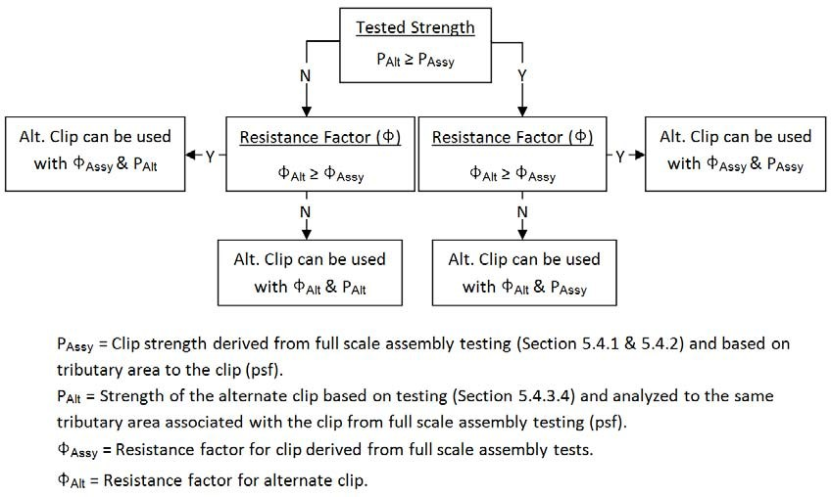

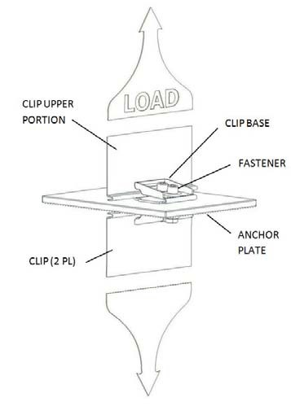
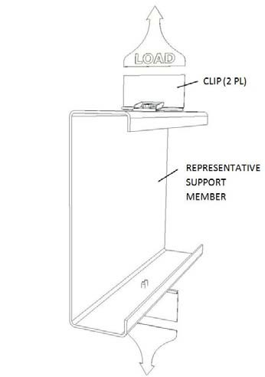
Figure 3: Clip Test Fixture - Typical Figure 4: Flexible Support Members

    - Clip / Fastener Attachment Schedules (Optional): Attachment schedules shall report the panel assembly’s calculated ASD or LRFD uplift loads based on various clip, fastener, and substrate combinations. Table 2 provides an acceptable attachment schedule format. In the determination of the ASD or LRFD loads specified in the attachment schedule, eccentric loading of the fasteners relative to the panel seam shall be taken into account. Clip fastener locations are commonly installed off-center of the clip loading centerline, which increases the loading of the fastener(s). Figure 5 shows an example of this eccentric loading.

Figure 5: Eccentric Loading of Fastener
L

Fastener load (L_{f}) = Load (L) x b
Lf
a
b
a

  - Diaphragm Shear Resistance (Optional): If included, diaphragm shear resistance shall be calculated or tested in accordance with AISI S310. All perimeter and interior connections shall be designed to develop the published diaphragm design strengths in accordance with provisions of AISI S310. Optionally, the evaluation report may indicate that the connections are permitted to be designed to resist the required strength only, such as for connections to shear transfer elements. Unless a special analysis is submitted, the spacing of fasteners connecting panels along longitudinal edges parallel to the deck flutes shall be no greater than the interior side-lap seam fastener spacing to maintain diaphragm stiffness.
The appropriate safety factors (Ω_{d}) and resistance factors (Φ_{d}) for calculating or testing diaphragms shall be used in accordance with Table B1.1 of AISI S310. If the nominal shear strength is only established by test without defining all limit state thresholds, the Ω_{d} and Φ_{d} shall also be limited by the values given in Table B1.1 for connection types and connection-related failure, and the more severe factored limit state shall control the design in accordance with Section B1.1 of AISI S310. Where a combination of connection types is used within a diaphragm configuration, the more severe factor shall be used in accordance with Section B1.1 of AISI S310.
For mechanical fasteners other than screws:
(a) Ω_{d} shall not be less than the Table B1.1 values for screws, and
(b) Φ_{d} shall not be greater than the Table B1.1 values for screws
Additionally, using the Ω_{d} and Φ_{d} factors for mechanical fasteners other than screws shall be limited by the safety and resistance factor values established through calibration of the individual fastener shear strength in accordance with Section D1.1.5 of AISI S310, as required in Section B1.1 of AISI S310.
  - Air and Water Infiltration Testing (Optional): If values are included in the Evaluation Report, air and water infiltration testing shall be performed in accordance with this section. If no water infiltration testing is submitted, then compliance with Statement 4 of Section 7.3 of this criteria for walls or Statement 6 of Section 7.3 of this criteria for roofs shall apply. If no air infiltration testing evidence is submitted, then the report shall indicate that the panels are not tested for air resistance and that air resistance is outside the scope of the report.

Roof Assemblies:

      - Air infiltration testing shall be performed in accordance with ASTM E1680.

      - Water infiltration testing shall be performed in accordance with ASTM E1646.

Wall Assemblies:

      - Air infiltration testing shall be performed in accordance with ASTM E283.

      - Wall panels may be tested for wind-driven rain in accordance with E331, subject to additional requirements in IBC Section 1403.2 (Exception 2) or IRC Section R703.1.1 (Exception 2). Wall panels that are not tested shall comply with Statement 3 of Section 7.3 of this criteria.

    - All air and water infiltration testing shall be performed and evaluated utilizing the minimum test pressure differences defined in each of the above noted ASTM test specifications.

    - For all air and water infiltration testing performed at a given panel gage, panel width, and panel attachment spacing that passes the test requirements, all variations of the same panel design that have a heavier gage, narrower width, and/or reduced attachment spacing shall be considered passing due to their inherently stronger design. The same “passed” tested assembly attachment type shall be used when extending to additional variations.

  - Fire Ratings (Optional): If included, testing for fire ratings shall be performed in accordance with this section. If no fire rating evidence is submitted, the report shall indicate that the fire rating of the roof or wall panels is beyond the scope of the report as applicable.

    - Roof Panels: Class A, B, or C roof assemblies or roof coverings shall be tested in accordance with ASTM E108 or UL 790. Testing is not required for roof assemblies complying with the requirements of IBC Section 1505.2 Exception No. 2, or IRC Section R902.1 Exception No. 2, which are classified Class A roof assemblies by definition.

    - Wall Panels: The fire-resistance rating of building components or assemblies shall be tested in accordance with ASTM E119 or UL 263.

  - Wind Blown Debris Resistance, Wall Panels (Optional): If included, windblown debris resistance testing shall be conducted in accordance with ASTM E1886 and ASTM E1996 with the modifications in IBC Section 1609.1.2.2. If no wind-borne debris resistance testing evidence is submitted, then the report shall indicate that the panels are not tested for wind borne debris resistance and that wind-borne debris resistance is outside the scope of the report.

  - Drag Load Resistance, Roof Panels (Optional): If included, drag load resistance tables shall present the type and number of, fasteners required to appropriately fix concealed fastener panels to supporting members to resist drag load forces created by snow and gravity loads.

QUALITY CONTROL

  - Inspections of manufacturing facilities are required for this product by the evaluation service agency or an accredited inspection agency. Inspections by inspection agencies accredited for metal products in accordance with ISO/IEC 17020 by an accreditation body recognized as conforming to ISO/IEC 17011 are permitted.

  - Quality documentation complying with IAPMO UES Minimum Requirements for Listee’s Quality Assurance System (ES-010) or equivalent shall be submitted.

EVALUATION REPORT RECOGNITION

  - Each bundle of panels shall have a visible product identification label affixed to it. Labels shall include the manufacturer’s name and address, the evaluation service agency logo, and the evaluation report number, and shall clearly identify the panel type, steel specification by ASTM or other recognized specification, and steel gage or thickness as listed in the evaluation report.

  - Mandatory items shall be included, and the optional items may be included in the evaluation report as shown in Table 1. Data supporting the mandatory and optional items that have found to comply with the requirements of this criteria shall be summarized in the evaluation report. Additional items may be included as determined appropriate by the evaluation service agency.

  - Evaluation report shall include the following or equivalent statements:

    - Metal panels used in roof applications shall be applied to a solid or closely fitted deck, except where the roof covering is specifically designed to be applied to spaced support members.

    - Calculations demonstrating compliance with this report shall be submitted to the code official for approval. The calculations shall be prepared by a licensed design professional where required by the statutes of the jurisdiction in which the project is to be constructed.

    - The evaluation report shall state that roof or wall panel resistance to air infiltration is outside the scope. Panels shall be permitted to be rated for resistance to air infiltration based on successful testing in accordance with Section 5.6.1.1 or 5.6.2.1 of this criteria.

    - Panels used on exterior walls shall be flashed in accordance with IBC Section 1405.4 or IRC Section R905.4.6 and be placed over a water-resistive barrier in accordance with IBC Sections 1402.2, 1403.2, and 1404.2 or IRC Section R703.1. Alternative means of weather protection shall be permitted based on successful testing in accordance with Section 5.6.2.2 of this criteria.

    - The evaluation report shall state the minimum allowable panel roof deck slopes for each listed panel type. The deck slopes shall not be less than minimums stated in IBC Section 1507.4.2 or IRC Section R905.10.2

    - The evaluation report shall include a statement that flashing requirements for roof assemblies, when applicable, shall comply with IBC Section 1503.2 and 1503.3 or IRC Section R903.2 and R903.3. Underlayment shall be installed in accordance with IBC Sections 1507.1 and 1507.4.5 considering applicable wind conditions. Alternative means of weather protection shall be permitted based on successful testing in accordance with Section 5.6.1.2 of this criteria.

    - The evaluation report shall state that roof panels are limited to installations complying with IBC Section 1505.2 Exception No. 2, or IRC Section R902.1 Exception No. 2 as Class A roof assemblies or where nonclassified roofing is permitted by the IBC or IRC. Other classifications and installation methods shall be permitted based on successful testing in accordance with Section 5.7.1 of this criteria.

    - The evaluation report shall state that wall panels are limited to installations where non-fire- resistance-rated construction is permitted by the IBC or IRC. Wall panels shall be permitted in fire-resistance-rated wall assemblies based on successful testing in accordance with Section 5.7.2 of this criteria.

    - The evaluation report shall state that panel use as protection of glazed openings located in wind- borne debris regions is outside the scope. Panels shall be permitted to be used as impact- resistant coverings based on successful testing in accordance with Section 5.8 of this criteria.

    - Design of panel penetrations and other panel discontinuities shall be the responsibility of the design professional using rational engineering mechanics or in accordance with the manufacturer’s installation instructions as approved by the building official.

    - For load combinations that include wind uplift, the nominal wind load shall be permitted to be multiplied by 0.67 provided the conditions in AISI S100-16, Appendix A, Section I6.3.1a (a through g) or AISI S100-12 and -07-S2-10 Appendix A Section D6.2.1a (a through g) are satisfied. The evaluation report shall state whether or not conditions A and D to G have been satisfied for each panel listed in the report. Report shall also state that compliance with conditions B and C are the responsibility of the design professional.

    - Where concealed or exposed fastener panels are qualified for optional vertical diaphragm shear resistance in walls of light-frame construction, the evaluation report shall state that for seismic design, the walls shall be classified as a “bearing wall system” or “building frame system” with “Light‐framed walls with shear panels of all other materials” subject to the conditions of this classification as defined in ASCE/SEI 7 Section 12.2.

    - Partial Panels, Openings, Holes, or Penetrations Through Steel Panels: The registered design professional may submit design calculations and opening details to the building official for approval based on the principles of mechanics for partial panels, openings, holes, or penetrations. For lateral force resisting systems (diaphragms and shear walls), the calculations shall consider the effects of partial panels, openings, holes, or penetrations on the overall strength and stiffness of the diaphragm or shear wall. Proprietary penetrations, holes, and openings shall be permitted and listed in the report if testing or calculations are submitted to the satisfaction of the accredited evaluation service agency.

Table 1: Required & Optional Evaluation Report Information

Item | Required | Optional
Section Properties (Section 5.1) | X
Design Base Metal Thickness per Gage Callout (Section 5.1) | X
Positive Load Test Results or Load Tables (Section 5.3) | X1
Negative Load Test Results or Load Tables (Section 5.4) | X1
Web Crippling (Section 5.3.1) | X2
Diaphragm Shear Resistance |  | X
Clip/ Fastener Attachment Schedule (Section 5.4.4) |  | X
Air Infiltration Testing (Section 5.5) |  | X
Water Infiltration Testing (Section 5.5) |  | X
Fire Ratings (Section 5.6) |  | X
Wind Blown Debris Resistance (Section 5.8) |  | X
Drag Load Resistance (Section 5.9) |  | X
Notes:
1 - Shall be an optional report item if load resistance is calculated based on panel section properties.
2 - Required if panel installation and supports conform to qualifications noted in Section 5.3.1.

Table 2: Clip/ Fastener Attachment Schedule (Matrix) (Ref. 5.4.4)

Columns of available panel attachment spans and maximum allowable panel uplift capacities at those spans based on testing and interpolation (as defined by Section 5.4 of this criteria).

Rows of available substrate and fastener combinations with allowable fastener pullouts (capacities determined in accordance with Section 5.2 of this criteria).
Matrix of allowable uplift loads based on uplift test data (above) and limited by fastener/substrate capacities at the left.

